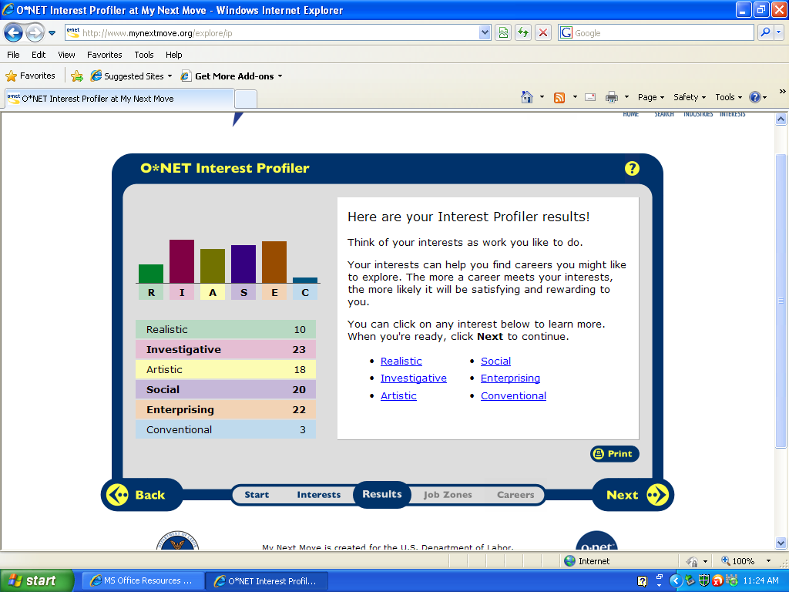
I think my results are accurate. I am involved in Model UN at school and am very interested in politics. I am also very interested in psychology. I like to figure out the reasons for which people do the things they do. I don’t think the survey was very accurate in the assessment of the artistic profiling. I am very involved in art classes and enjoy art very much. This didn’t seem to come through in the survey.

HR1. What is the definition of each occupation that your group has chosen and the nature of the work?
HR2. What are some of the related occupational fields?
HR3. Which personality type(s) is best suited to the occupations/jobs you have researched?
HR4. What kind of education, training and qualifications are required?
HR5. What technology skills are needed to be successful in the career/occupational fields you have explored?
RC1. What does each occupation pay, or what are the average earnings nationally and in this area of the country?
RC2. What is the projected growth for this career field over the next 10 years? (i.e. will there be more or less jobs like this in the future?)
RC3. Please identify local or national organizations that would hire someone in each career field you have explored.
ISC1. What are the working conditions or work environment for each job you or your group decided to research (such as work schedule, hours, exempt/salaried or non-exempt/hourly, etc.)?
ISC2. Are positions in this career field typically part of collective bargaining units (unions)?
ISC3. What kind of opportunities for advancement are there for each career? (i.e. Is there a chance to get promoted, etc.?)

Psychologist
  - A psychologist is someone who diagnoses and treats mental disorders; learning disabilities; and cognitive, behavioral, and emotional problems, using individual, child, family, or group therapies. They may design and implement behavior modification programs
  - Occupations related to psychology are Child, Family, and School Social Workers , Directors, Religious Activities and Education, Educational, Guidance, School, and Vocational Counselors, and Elementary School Teachers, excluding Special Education.
  - A Psychologist must be traditional, loyal, quiet and kind. They are very sensitive to other people's needs because they are very observant. They have rich inner thoughts and emotions. They value stability and cultural norms. They are very adept at giving attention to detail. They do not seek positions of authority. They are generally observant, stable and motivated by a need to maintain security. They are realistic, reutilized administrators requiring tasks be completed correctly and that people behave appropriately. They make thorough examinations to ensure everything is done according to plan. They make sure no more and no less credit is given than due. When a need arises, they are quick to provide a solution, provided that the need is justified. Psychologists are not driven by impulse, but rather by concrete fact. By virtue of their reliable, diligent, industrious, persevering nature, they make excellent leaders.

- Distribution of Educational Attainment
Occupation | Percent of employees aged 25 to 44 in the occupation whose highest level of educational attainment is
 | Less than high school diploma | High school diploma or equivalent | Some college, no degree | Associate's degree | Bachelor's degree | Master's degree | Doctoral or professional degree
Clinical, counseling, and school psychologists | 0.2% | 0.2% | 0.4% | 0.3% | 4.2% | 43.2% | 51.5%
Social Scientists and Related Workers | 0.2% | 1.5% | 5.5% | 2.9% | 30.2% | 37.2% | 22.4%
Life, Physical, and Social Science | 1% | 5.7% | 9% | 5.3% | 33.9% | 25% | 20%
Total, All Occupations | 10.7% | 27.6% | 20.6% | 8.9% | 19.4% | 8.3% | 4.5%
5. Technology:
- Accounting software - MPMsoft billing software
- Analytical or scientific software - Comprehensive Affect Testing System CATS, Noldus Information Technology The Observer, Statistical software, Testing software
- Calendar and scheduling software - SpectraSoft AppointmentsPRO
- Internet browser software - Web browser software
- Medical software - Addison Health Systems WritePad, Anasazi Software Client Data System, Athena Software Penelope Case Management, B Sharp Technologies B Care, BRB Software HorizonMIS
6.
Location | Pay  Period | 2010
 |  | 10% | 25% | Median | 75% | 90%
United States | Hourly | $18.76 | $24.21 | $32.12 | $41.47 | $52.24
 | Yearly | $39,000 | $50,400 | $66,800 | $86,300 | $108,700
Massachusetts | Hourly | $17.47 | $24.68 | $34.03 | $43.79 | $53.81
 | Yearly | $36,300 | $51,300 | $70,800 | $91,100 | $111,900
7.
United States | Employment |  | Percent  Change | Job Openings ¹
 | 2008 | 2018
Clinical, counseling, and school psychologists | 152,000 | 168,800 | +11% | 5,990
Massachusetts | Employment |  | Percent  Change | Job Openings ¹
 | 2008 | 2018
Clinical, counseling, and school psychologists | 6,480 | 6,810 | +5% | 220
8. Psychologists employed as faculty by colleges and universities divide their time between teaching and research and also may have administrative responsibilities; many have part-time consulting practices.

9. Psychologists’ work environments vary by subfield and place of employment. For example, clinical, school, and counseling psychologists in private practice frequently have their own offices and set their own hours. However, they usually offer evening and weekend hours to accommodate their clients. Those employed in hospitals, nursing homes, and other health care facilities may work shifts that include evenings and weekends, and those who work in schools and clinics generally work regular daytime hours. Most psychologists in government and industry have structured schedules. Increasingly, many psychologists work as part of a team, consulting with other psychologists and professionals. Many experience pressures because of deadlines, tight schedules, and overtime. Their routine may be interrupted frequently. Travel may be required in order to attend conferences or conduct research.
14 hrs per day
10. No
11. Not really
Political Scientist
  - Study the origin, development, and operation of political systems. Research a wide range of subjects, such as relations between the United States and foreign countries, the beliefs and institutions of foreign nations, or the politics of small towns or a major metropolis. May study topics, such as public opinion, political decision making, and ideology. May analyze the structure and operation of governments, as well as various political entities. May conduct public opinion surveys, analyze election results, or analyze public documents.

- Some political scientists move on to law school. A few become consultants to political groups, organizations, businesses and industries. The vast majority who end up in teaching posts at colleges and universities also establish double careers as writers and researchers. A few hold positions as directors or department heads of college programs.

Claims Examiners, Property and Casualty Insurance
Insurance Adjusters, Examiners, and Investigators
Licensing Examiners and Inspectors
Assessors
Title Examiners, Abstractors, and Searchers
Criminal Investigators and Special Agents
3. Generally, people who choose to earn a degree in Political Science tend to have strong leadership skills, are very outgoing and enjoy public speaking.
4. People with Poli Sci degrees work in various fields, including journalism, international affairs, finance and more. With higher degrees in Political Science, many people end up teaching at the post-secondary level or working for the Senate, the House of Representatives, the CIA and more. There are also many who use their Political Science degrees as a stepping stone for a career as an attorney.
78 | Doctoral or professional degree
17 | Master's degree
4 | Bachelor's degree  Most of these occupations require graduate school. For example, they may require a master's degree, and some require a Ph.D., M.D., or J.D. (law degree).

5.
6.
1 | Virginia | $60.69 | $126,200
2 | District of Columbia | $57.33 | $119,200
3 | NEW YORK | $53.22 | $110,700
 | UNITED STATES | $51.65 | $107,400
4 | Washington | $32.22 | $67,000
7.
United States | Employment |  | Percent  Change | Job Openings ¹
 | 2008 | 2018
Political scientists | 4,100 | 4,900 | +19% | 280

8. As a political Scientist, I could be employed by various universities as a professor or by the federal/state government.
9. Most sociologists and political scientists have regular hours. Generally working behind a desk, either alone or in collaboration with other social scientists, they read and write research articles or reports. Many experience the pressures of writing and publishing, as well as those associated with deadlines and tight schedules. Some sociologists may be required to attend meetings. Political scientists on foreign assignment must adjust to unfamiliar cultures, climates, and languages.
10. no
11. Many sociologists and political scientists choose to teach in their field, often while pursuing their own research. These workers are usually classified as postsecondary teachers. The minimum requirement for most positions in colleges and universities is a Ph.D. degree. Graduates with a master's degree in sociology or political science may qualify for teaching positions in community colleges.
Architecture
- People need places in which to live, work, play, learn, worship, meet, govern, shop, and eat. Architects are responsible for designing these places, whether they are private or public; indoors or out; rooms, buildings, or complexes. Architects are licensed professionals trained in the art and science of building design who develop the concepts for structures and turn those concepts into images and plans.
- Engineers
Landscape architects
Urban and regional planners
Architects design buildings and related structures. Other occupations with design responsibilities include:
Commercial and industrial designers
Graphic designers
Interior designers
- INTPs live in the world of theoretical possibilities. They see everything in terms of how it could be improved, or what it could be turned into. They live primarily inside their own minds, having the ability to analyze difficult problems, identify patterns, and come up with logical explanations. They seek clarity in everything, and are therefore driven to build knowledge. They are the "absent-minded professors", who highly value intelligence and the ability to apply logic to theories to find solutions."
- A bachelor's degree in graphic design is usually required for most entry-level and advanced graphic design positions. Bachelor's degree programs in fine arts or graphic design are offered at many colleges, universities, and private design schools. Most curriculums include studio art, principles of design, computerized design, commercial graphics production, printing techniques, and Web site design. In addition to design courses, a liberal arts education that includes courses in art history, writing, psychology, sociology, foreign languages and cultural studies, marketing, and business are useful in helping designers work effectively. Associate degrees and certificates in graphic design also are available from 2-year and 3-year professional schools, and graduates of these programs normally qualify as assistants to graphic designers or for positions requiring technical skills only. Creative individuals who wish to pursue a career in graphic design—and who already possess a bachelor's degree in another field—can complete a 2-year or 3-year program in graphic design to learn the technical requirements.
- Computer aided design CAD software - AutoDesSys form Z, Autodesk 3ds Max for Design Visualization, Autodesk Architectural Studio, Autodesk AutoCAD software, Autodesk Revit
Data base user interface and query software - Database software, FEMA EMMIE, Microsoft Access
Document management software - Adobe Systems Adobe Acrobat software, CADFind Sketch & Search software, FileNet P8 software
Graphics or photo imaging software - Adobe Systems Adobe Illustrator, Adobe Systems Adobe Photoshop software, Micro-Press MicroStation PowerDraft
Project management software - Craftsman CD Estimator, Microsoft Project, Primavera Systems software, Turtle Creek Software Goldenseal (project management feature)

Location | Pay  Period | 2010
 |  | 10% | 25% | Median | 75% | 90%
United States | Hourly | $20.61 | $26.27 | $34.88 | $44.72 | $57.45
 | Yearly | $42,900 | $54,600 | $72,600 | $93,000 | $119,500
Massachusetts | Hourly | $22.00 | $28.77 | $38.30 | $47.58 | $61.85
 | Yearly | $45,800 | $59,800 | $79,700 | $99,000 | $128,600
7.
United States | Employment |  | Percent  Change | Job Openings ¹
 | 2008 | 2018
Architects, except landscape and naval | 141,200 | 164,200 | +16% | 4,680
Massachusetts | Employment |  | Percent  Change | Job Openings ¹
 | 2008 | 2018
Architects, except landscape and naval | 5,400 | 5,740 | +6%
    - As an architect, I could be hired by any facility needing a building (schools, banks, offices, etc.) or the federal/national government.
    - Architects may feel stressed sometimes. Most architects work 40 hours a week, but they may need to work nights and weekends in order to meet deadlines.
    - No
    - With a few years of experience a landscape architect may become a project manager. Two out of every 10 landscape architects become self employed.
Physician
  - Physicians diagnose and treat injuries and illnesses in patients. Physicians examine patients, take medical histories, prescribe medications, and order, perform, and interpret diagnostic tests.
  - Chiropractors, Dentists, Optometrists, Physician’s Assistants, Podiatrist
  - Social

Most applicants to medical school have at least a bachelor's degree, and many have advanced degrees. While a specific major is not required, all students must complete undergraduate work in biology, chemistry, physics, mathematics, and English. Students also take courses in the humanities and social sciences. Some students volunteer at local hospitals or clinics to gain experience in a healthcare setting. Students spend most of the first 2 years of medical school in laboratories and classrooms, taking courses such as anatomy, biochemistry, pharmacology, psychology, medical ethics, and the laws governing medicine. They also gain practical skills, learning to take medical histories, examine patients, and diagnose illnesses. During their last 2 years, medical students work with patients under the supervision of experienced physicians in hospitals and clinics. Through rotations in internal medicine, family practice, obstetrics and gynecology, pediatrics, psychiatry, and surgery, they gain experience in diagnosing and treating illnesses in a variety of areas. After medical school, almost all graduates enter a residency program in the specialty they are interested in. A residency usually takes place in a hospital and varies in duration, usually lasting from 3 to 8 years, depending on the specialty.

- Accounting software - Billing software
- Electronic mail software - Email software
- Information retrieval or search software - Medical reference software
- Internet browser software - Internet browser software
- Medical software - Computerized physician order entry CPOE software, Electronic medical record EMR software, Epocrates Essentials, MDeverywhere, Medical decision support software

Location | Pay  Period | 2010
 |  | 10% | 25% | Median | 75% | 90%
United States | Hourly | $25.73 | $53.77 | $80.00+ | $80.00+ | $80.00+
 | Yearly | $53,500 | $111,800 | $166,400+ | $166,400+ | $166,400+
Massachusetts | Hourly | $24.01 | $32.30 | $80.00+ | $80.00+ | $80.00+
 | Yearly | $49,900 | $67,200 | $166,400+ | $166,400+ | $166,400+

United States | Employment |  | Percent  Change | Job Openings ¹
 | 2008 | 2018
Physicians and surgeons | 661,400 | 805,500 | +22% | 26,050
Massachusetts | Employment |  | Percent  Change | Job Openings ¹
 | 2008 | 2018
Physicians and surgeons | 22,010 | 24,210 | +10% | 610

- Many physicians work in private offices or clinics, often helped by a small staff of nurses and administrative personnel.
- Increasingly, physicians work in group practices, health care organizations, or hospitals where they share a large number of patients with other doctors.

Many physicians and surgeons work long, irregular, and overnight hours. Physicians and surgeons may travel between their offices and hospitals to care for their patients. While on call, a physician may need to address a patient’s concerns over the phone or make an emergency visit to a hospital or nursing home.
10. no
11.
Physician Assistant
  - Provide healthcare services typically performed by a physician, under the supervision of a physician. Conduct complete physicals, provide treatment, and counsel patients. May, in some cases, prescribe medication.
  - Anesthesiologists, chiropractor, dentist, nuclear medicine technologists
  - Social

- Most applicants to physician assistant education programs already have a bachelor’s degree and some healthcare-related work experience. However, admissions requirements vary from program to program.
- Many assistants already have experience as registered nurses, emergency medical technicians (EMTs), or paramedics before they apply to a physician assistant program.
- Physician assistant education programs usually take at least 2 years of full-time study. Most of accredited programs offer a master’s degree. Others offer a bachelor’s degree, and a very few award an associate’s degree or graduate certificate.
5.
- Internet browser software - Web browser software
- Medical software - ChartWare software, Electronic medical record EMR software
- Spreadsheet software - Spreadsheet software
- Storage media loading software - Patient records software for personal digital assistants PDAs
- Video conferencing software - Teleconferencing software

6.
Location | Pay  Period | 2010
 |  | 10% | 25% | Median | 75% | 90%
United States | Hourly | $27.62 | $35.12 | $41.54 | $48.89 | $56.60
 | Yearly | $57,400 | $73,000 | $86,400 | $101,700 | $117,700
Massachusetts | Hourly | $23.31 | $35.78 | $43.86 | $51.10 | $56.73
 | Yearly | $48,500 | $74,400 | $91,200 | $106,300 | $118,000

United States | Employment |  | Percent  Change | Job Openings ¹
 | 2008 | 2018
Physician assistants | 74,800 | 103,900 | +39% | 4,280
Massachusetts | Employment |  | Percent  Change | Job Openings ¹
 | 2008 | 2018
Physician assistants | 2,810 | 3,480 | +24% | 120
8.
Offices of physicians | 54%
Hospitals; state, local, and private | 24%
Outpatient care centers | 9%
Government | 4%
Colleges, universities, and professional schools;  state, local, and private | 3%

9. Physician assistants spend much of their time on their feet, making rounds and evaluating patients. Physician assistants who work in operating rooms often stand for extended periods.
Most physician assistants work full time. About 13 percent reported working 50 hours or more per week in 2010. In hospitals, physician assistants may work nights, weekends, or holidays. They may also be on call, meaning they must be ready to respond to a work request with little notice.

10. no
11. The nature of this job usually precludes advancement in the typical sense as roles for management are limited. Job opportunities are good and income should keep pace with other healthcare professions. Opportunities exist to become an educator or college instructor.
Neurology

Physicians specializing in the field of neurology are called neurologists and are trained to diagnose, treat, and manage patients with neurological disorders. Neurologists may also be involved in clinical research, clinical trials, as well as basic research and translational research.
  - Chiropractors, Dentists, Optometrists, Physician’s Assistants, Podiatrist
  - Social/Investigative/Realistic

- They have to complete four years of premed (undergraduate) education, where they are required to study physics, biology, inorganic and organic chemistry, mathematics, and English. Premed is followed by four years of study in medical school and three to four years of internship, depending on the specialization chosen by the neurology student. The internship period consists of a year of training in internal medicine, followed by three years of training in neurological diagnostic procedures. That equals a total of about twelve years of postsecondary education.
5.
- Internet browser software - Web browser software
- Medical software - ChartWare software, Electronic medical record EMR software
- Spreadsheet software - Spreadsheet software
- Storage media loading software - Patient records software for personal digital assistants PDAs
- Video conferencing software - Teleconferencing software

- The median yearly salary for neurologists in the United States is $178,564. The lowest 10 percent of neurologists (in terms of earnings) make less than $150,000 annually. The upper 10 percent make more than $208,000 every year. Neurologists with excellent work experience may even make as much as $300,000 yearly. Geographical location is another deciding factor when it comes to earning a better salary. For instance, neurologists working in the states of Minnesota, Nevada, South Dakota, New Hampshire, and Indiana report an average annual salary of $203,000, significantly over the national average.
- Read more: Neurologist Job Description, Career as a Neurologist, Salary, Employment - Definition and Nature of the Work, Education and Training Requirements, Getting the Job - StateUniversity.com http://careers.stateuniversity.com/pages/7864/Neurologist.html#ixzz1uZsvwczk
7. $178,564 per year
8. hospitals, private practices
9. Working conditions are usually pleasant with the work environment being indoors in well lighted exam rooms and hospitals. Hours of work frequently exceed 60 hours a week in the busier practices. This typically can result in being awakened at all hours of the night and/or being asked to come in at irregular times to evaluate a patient.

10. No
11. The outlook for physicians is projected to be very good. Significant shortages exist in rural and underserved areas. The trend towards group practices will provide opportunities for more doctors to hold positions of leadership and authority. This still remains one of the best paying professions in the healthcare industry.

I have narrowed my career choices to a psychologist and a physician’s assistant. I used information from previous research to make charts that show yearly wages, years of schooling, and expected growth in the next ten years for each job. The growth in the field of physician’s assistants is expected to grow the most in the next ten years. This is an important thing to consider with the unemployment rates and falling economy. I chose Psychologist because I found out that although most psychologists have a doctoral degree, some practice as social workers with less than a doctoral degree. This is positive because if I were to decide that I didn’t want to attend even more school, I could have a plan to fall back on. I have also discovered that things pertaining to psychology interest me the most. I have been able to talk to a few psychologists and figure out what exactly a day for them would be like.
Colleges:
- Vanderbilt University
  - Medical Scientist
- Marriage and Family Therapy
- Psychology, General
- George Washington University
  - Biology/Biomedical Sciences
  - Clinical Psychology
  - Counseling Psychology
- Duke University
  - Biology/Biomedical Sciences
  - Clinical Psychology
  - Psychology, General

